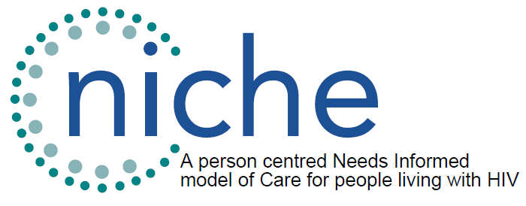

NICHE Patient and Public Involvement (PPI) Advisory Group:
Expression of interest form

Please complete this form and send to alex@ght.org.uk

About you
Name
Email address

Previous experience
Whilst not compulsory, please let us know of any experience of representing people living with HIV in research, in community organisations through co-production initiatives or in other ways.

Why are you interested in being involved?
In a couple of sentences please let us know why you wish to take part and help us shape the research programme.

